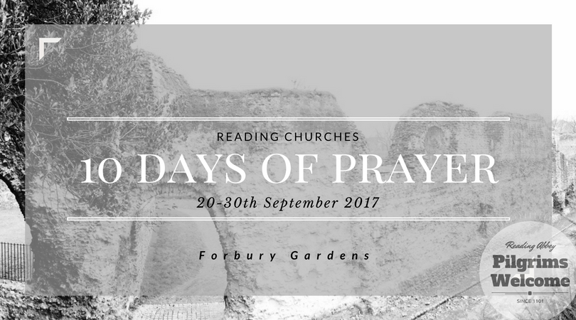

Dear all

Thank you for volunteering to lead worship, play instruments and assist with the event in other technical matters. We’re really excited about worshiping God in a public space and we have a strong hunch that the He is too!

Just so you know we have arranged insurance for both normal indemnity and also cover for certain pool instruments that will be used by several bands.

If you are bringing your own instruments then please ensure that you have them covered in your house insurance (alternatively, keep an eye on the instrument) as we are in a public place and whilst we believe that no believer will take anything not belonging to them we do not know if everybody coming through the doors of the tent has the same moral code.

Thanks loads for being a part of this. We look forward to meeting you at the tent!

Big blessings,

The 10 Days Of Prayer Team